

Form for ID card Request ( Send PP size Photo )

Province Board Members ID CARD SAMPLE

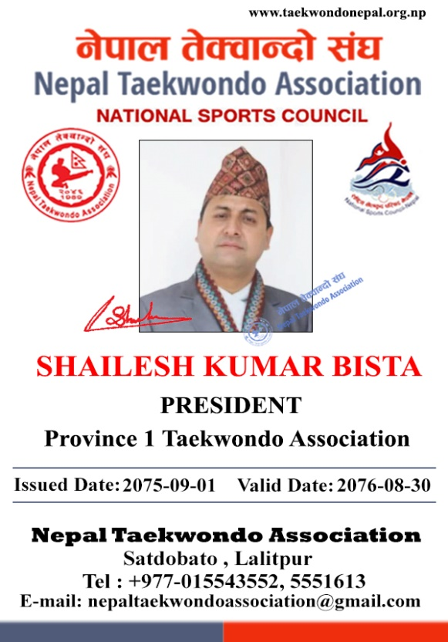1) Province no

….………………………………………………………..

2) Name

….………………………………………………………..

3) Position

….………………………………………………………..



Form for ID card Request ( Send PP size Photo )

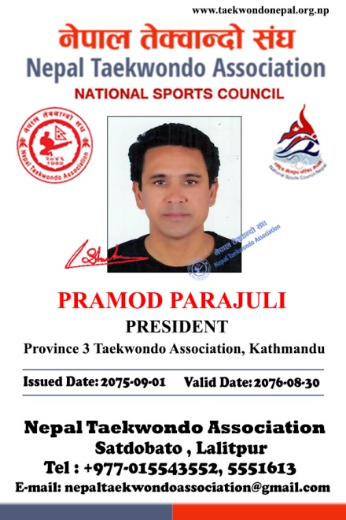District Board Members ID CARD SAMPLE

1) Province no & District

….………………………………………………………..

2) Name

….………………………………………………………..

3) Position

….………………………………………………………..



Form for ID card Request ( Send PP size Photo )

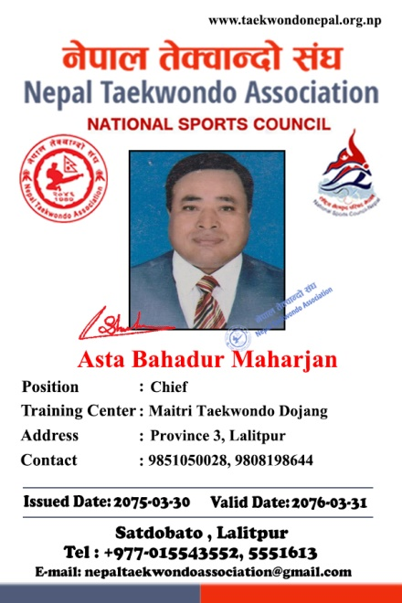Dojang Holders ID CARD SAMPLE

1) Province no & District

….………………………………………………………..

2) Name

….………………………………………………………..

3) Position

….………………………………………………………..

4) Name of Training Center

….………………………………………………………..

4) Contact

….………………………………………………………..